LabWindows / CVI Adapter
TestStand Version: 4.0
Author: Sathish Srinivasan
Feature Spec: LabWindows / CVI Adapter
Dependencies: LabWindows/CVI

Test Category: [Functional]

Description
Test all possible options. Look at the adapter documentation to help you better understand all the options available.

Preparation
- Install the version of TestStand under test.
- Install the latest released CVI version.
- Sync //TestStand/Tests/TS Automated Tests/3.0/flexCVIAdapter/ and //TestStand/Tests/CVI Tests/Automated/2.0/CVIAdp/
- If the sequences fail because it cannot create handles to objects, it may be that the server registration failed. Run TestStand as administrator so that it can successfully register the necessary exe and dll servers.
Note: For 2013 and later: You must enable backdoor registry key are restart TestStand to test the non-DLL modules, refer to the Spec for more details. Set 0x1 for the DWORD registry key EnableCVILegacyModules under HKEY_LOCAL_MACHINE\SOFTWARE\Wow6432Node\National Instruments\TestStand

Validation
Automated testing
- Run the automated test sequence for CVI and verify that it doesn’t fail under out-of-process and in-process modes. The sequence can be found on perforce under:
- TestStand\Tests\TS Automated Tests\3.0\flexCVIAdapter\AllCVITest.seq

Legacy Modules:
- Run the following CVI examples from TestStand 2.0
      - Examples\AccessingArrays
      - Examples\AccessingPropertiesAndVariables
      - Examples\Demo
Edit, create code and verify source prototype using the specify module dialog for CVI
    - Create code
      - Open the sequence editor, add a new sequence and insert a CVI action step. Open the specify module dialog for it.
      - Specify a new module pathname, function name and add an assorted set of parameters to the function; add integers, arrays, and so on, passing them by value or by reference.
      - Create local variables for the parameters you added.
      - Relate parameters and variables, using the function call edit box, for example type: test(&Locals.myInt, Locals.myArrayOfStrings) and click on the accept button.
      - Now switch to the Source Code tab, fill the appropriate fields, check on the Use Prototype from Module Tab check box and click on the create code button.
      - Build the created project and made sure the function in the dll is callable from TestStand.
      - Redo this step several times trying different settings, some of them wrong or invalid, each time.
      - Try to create code over a function that already exists and see that the Generate Code dialog appears.
      - Verify that create code for an array only puts the dimension size in the code for dimension sizes that are constant. For example, if you have a dimension with a size expression of Locals.foo, create code should omit the dimension size instead of using Locals.foo.
- Edit code
      - Open the specify module from one of the CVI steps created on the previous section.
      - Go to the source code tab and click on the Edit Code button.
      - The source file for the function should be opened on CVI and shown on the front.
      - Change the name of the function on the source file and/or on the specify module dialog and see that a run-time error is reported.
- Verify the prototype
      - Open the specify module from one of the CVI steps created on the previous section.
      - Go to the source code tab and click on the Verify Prototype button. A message stating that source and step prototypes are equivalent should appear.
      - Change the source and/or step prototype, click on the Verify Prototype button. A Prototypes Conflict dialog should appear. Select different options and see that TS behaves accordingly.
      - Verify that Verify Prototype doesn't compare the dimension size of the first dimension in an array. For example, the C/C++ compiler treats parameters of type ary[][3], ary[2][3], and ary[3][3] as the same.
      - Test Verify Prototype for structs and enums. You have to use the 'struct' and 'enum' keyword in the source code. Test both structs of type tsErrorDataType, which corresponds to the TestStand Error container, as well as structs you define.
Debugging support for CVI
- In-Process
      - Open the CVI project for a dll used on a TestStand sequence.
      - Set TestStand as an external process in the CVI environment.
      - Set breakpoints on the DLL source code.
      - Run the DLL. This will launch TestStand.
      - Open a sequence with CVI steps that call into the dll. Run the sequence and verify that all breakpoints are being honored.
      - Check the behavior of Step Out, Finish Function and Terminate Execution in CVI and TestStand.
      - If you are testing CVI 2010 or later, test detaching and reattaching to/from the sequence editor. Test detaching when you are paused on a line of code inside of CVI, and when you are paused on a step in the sequence editor. Also test detaching while your sequence is actively running.
      - Have tests which cause access violations (deref a null pointer). If you are not running TestStand as an external process through CVI, TestStand should recover from this error.
- Out-of-Process
      - Ensure that Execute Steps in an External Instance of CVI is selected on the LabWindows/CVI Adapter configuration dialog.
      - Open a TS sequence with CVI steps. Set breakpoints on CVI steps and run the sequence.
      - Once you are in a CVI step, use step into to go to the CVI environment. View some parameters and verify that they have correct values.
      - Check the behavior of Step Out, Finish Function and Terminate Execution in CVI and TestStand.
      - If you are testing CVI 2010 or later, test detaching and reattaching to/from the sequence editor. Test detaching when you are paused on a line of code inside of CVI, and when you are paused on a step in the sequence editor. Also test detaching while your sequence is actively running.
      - Verify that TestStand comes to the front when you continue execution out of the CVI module. Step into a module that displays a CVI panel (Examples\Demo\C\Computer.seq), use Finish Function and verify that TestStand comes to front after panel is dismissed.
      - Have tests which cause access violations (deref a null pointer). TestStand should recover from this error.
NOTE: In order to step into the dll, it must have debug information.
Working with .obj, .c and .lib modules
Note: For 2013 and later: You must enable backdoor registry key are restart TestStand to test the non-DLL modules
  - In-Process .obj, .lib
    - In CVI, open Tests\CVI Tests\Automated\2.0\CVIAdp\CVIAdpTest.prj
    - Open CVIAdpTest.c and select “Create Object File” in Options menu.
    - Verify you get a dialog showing the .obj file created successfully.
    - In Sequence Editor, select Adapters in Configure menu.
    - Select LabWindows/CVI and click on Configure.
    - Select “Execute Steps In-Process”. Click OK.
    - Click Done in Adapter Configuration dialog.
    - Open Tests\CVI Tests\Automated\2.0\CVIAdp\CVIAdpTest.seq
    - Select “TestData OBJ Test” sequence.
    - Place a break point in the first step and run TestData OBJ Test sequence.
    - On step breaks, Verify you cannot Step-Into it.
    - Repeat the steps 9 to 11 with “TestData CFile Test” and “TestData LIB Test” sequences selected.
Note: Debugging support In-process only works for dll modules, not for c, obj and lib modules.
  - Out-of-Process .obj, .lib, .c [CVI 2013 or later does not have support for .c files. Refer spec]
    - In CVI, open Tests\CVI Tests\Automated\2.0\CVIAdp\CVIAdpTest.prj
    - Select Target Settings in Build menu.
    - Enable LoadExternalModule and Click on “Add Files to DLL…”
    - Select tsapicvi.obj and tsutil.obj and click OK.
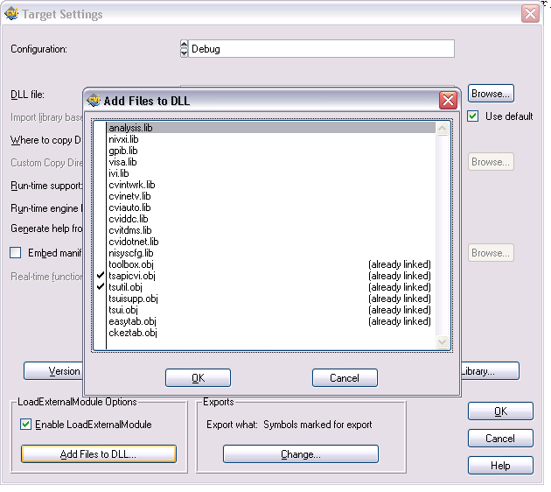
    - Open CVIAdpTest.c and select “Create Object File” in Options menu.
    - Verify you get a dialog showing the .obj file created successfully.
    - In Sequence Editor, select Adapters in Configure menu.
    - Select LabWindows/CVI and click on Configure.
    - Select “Execute Steps in an External Instance of LabWindows/CVI”. Click OK.
    - Click Done in Adapter Configuration dialog.
    - Open Tests\CVI Tests\Automated\2.0\CVIAdp\CVIAdpTest.seq
    - Select “TestData OBJ Test” sequence.
    - Place a break point in the first step and run TestData OBJ Test sequence.
    - On step breaks, Verify you cannot Step-Into it.
    - You might get an error as displayed below. Click Yes to add files to project.
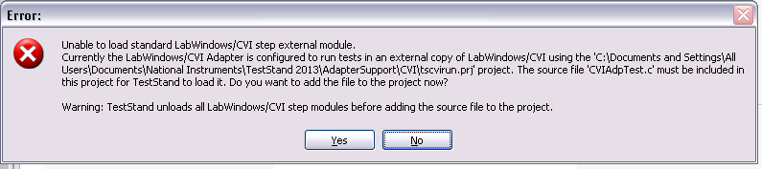
    - Repeat the steps 12 to 14 with and “TestData LIB Test” sequences selected.
    - Repeat the steps 12 to 14 with and “TestData CFile Test” sequences selected. But this time verify you can Step-Into C file.
NOTE: Debugging support Out-of-process only works for dlls and c modules not for obj and lib modules. Test debugging supports for a .c file.
Make sure that you add any support libraries needed for linking .obj and .lib files.
Structure passing
  - Make sure all data in the structures is being passed in and all data passed back is unpacked correctly. Test all data types.
  - Verify that passing nested structures works.
  - Test passing structure parameters by value and by reference.
  - Test struct property page in types.
Use CVI Adapter API
  - Add a new CVI step to an empty sequence.
  - Then use an expression or (if pre 4.0) add an ActiveX call to change settings on the step using Adapter API.
  - Verify that all changes have been properly made.
  - Verify that any invalid change is rejected.
Type library reading
  - Load various DLLs and verify that type library information is used correctly (ie. that function prototypes displayed are accurate) Make sure all types are tested.
  - Test functions that have enum parameters. Verify that the enum name appears in the dialog and that we pass the correct values (dialog will not display possible enumeration values because that information is not available form the DLL).
  - Test with parameter types not supported (e.g. char **) to see if an error message is reported correctly and/or this case is handled in a reasonable way.
  - For CVI Dlls with debug information test that prototype data is used correctly (ie. that function prototypes displayed are accurate) Make sure all types are tested.
Memory leak detection
Use perfmon.mnc to monitor private bytes for the desired process. Type perfmon.msc on the run command to start Windows Performance Monitoring tool. Make sure that the Maximum value for private bytes is not constantly going up.
- In-process. Verify that TestStand process (SeqEdit) is not leaking memory.
    - Ensure that Execute Steps In-Process is selected on the LabWindows/CVI Adapter configuration dialog.
    - Create release dlls for all the dlls used on AllCVITest.seq
    - Run sequence over-night and verify that there aren’t any memory leaks.
    - Create debug dlls for all the dlls used on AllCVITest.seq
    - Run sequence over-night and verify that there aren’t any memory leaks.

- Out-of-process. Verify that TestStand (SeqEdit), tscvirun (tscvirun_dbg) and CVI (cvi) processes are not leaking memory.
    - Ensure that Execute Steps in an External Instance of CVI is selected on the LabWindows/CVI Adapter configuration dialog.
    - Create release dlls for all the dlls used on AllCVITest.seq
    - Run sequence over-night and verify that there aren’t any memory leaks.
    - Create debug dlls for all the dlls used on AllCVITest.seq
    - Run sequence over-night and verify that there aren’t any memory leaks.

- Standard Test for Adapters
- Standard Test for Dialogs
- Validate CARs 379312 and 379299.
- Verify the behavior added for CAR 433955. Specifically, for 64-bit TestStand, set the CVI adapter to run out-of-process.
  - Verify that when the CVI 2013 (plain 2013, not SP1) ADE is used, you get a run-time error that the version of CVI is too old.
    - Verify that no error occurs running in-process for the same situation. (This is really just to validate your test case works.)
    - Verify that no error occurs for 32-bit TestStand in the same situation. (You will need a 32-bit version of the DLL for this, of course.)
  - Verify that when the CVI 2013 SP1 ADE is used to run the CVI step out-of-process with 64-bit TestStand, it works without error. (There is no need to check 32-bit or in-process 64-bit for this case.)
    - Create a custom step type with a default prototype that returns an integer. In this step type’s return value parameter, set the default values of the ResultAct to 1. Set the default Flags subproperty (not to be confused with the flags of a property) to have the 2 bit set (preserving the other bits). For ResultAct and Flag properties, set the “Not Editable” flag.
Note: “Not Editable” is set for a subproperty by right-clicking on the property and selecting “Properties…” à “Advanced” à “Flags” à “Type Flags…” à and setting “PropFlags_NotEditable” for both the “Instance Default Flags” and “Flags Not Editable in Instances.”
    - Create instances of each of these custom step types in the Sequence Editor and validate the following for the return values:
      - “Set Error.Code” is checked. (This field is controlled by the 0x2 bit of Flags.)
      - “Result Action” is “If Value < 0 Set Error.Occurred to True.”
      - The “Category”, “Type”, “Result Action”, and “Set Error.Code” fields should be read-only. For other parameters these fields should not be read-only.
      - Add a parameter to the prototype, then refresh the prototype, removing the parameter you just added. Verify #1, #2, and #3 above.
      - Change to a different prototype that returns void. Then change to a third prototype that returns int. Verify #1, #2, and #3 above.
    - Create two new custom step types similar to the ones above, but in these make either the Flags subproperty or the ResultAct subpropery (but not both simultaneously) not editable.
  - With just the Flags not editable:
  - Verify that none of the fields “Category”, “Type”, or “Set Error.Code” can be modified.
  - Verify that the “Result Action” field can be changed.
  - With just the Result Action not editable:
- Verify that the “Category”, “Type,” and “Set Error.Code” fields can be modified.
- Verify that the “Result Action” field cannot be changed.
- Verify that when you change the “Category” to “Void” and then back to “Numeric” that the “Result Action” remains unchanged and not editable.
    - Do some free-form testing.

National Instruments Confidential
Copyright © 2005 National Instruments Corporation

